# Modules Introduction

## Rain Drop Sensor

Raindrop Sensor is a tool used for sensing rain. It consists of two modules, a rain board that detects the rain and a control module, which compares the analog value, and converts it to a digital value. The raindrop sensors can be used in the automobile sector to control the windshield wipers automatically, in the agriculture sector to sense rain and it is also used in home automation systems.

Raindrop sensor is basically a board on which nickel is coated in the form of lines. It works on the principal of resistance. When there is no rain drop on board. Resistance is high so we gets high voltage according to V=IR. When rain drop present it reduces the resistance because water is conductor of electricity and presence of water connects nickel lines in parallel so reduced resistance and reduced voltage drop across it. The more intense the rainfall the lower the resistance.

The rain sensor module/board is shown below. Basically, this board includes nickel coated lines and it works on the resistance principle. This [sensor module](https://www.elprocus.com/pir-sensor-circuit-with-working/) permits to gauge moisture through analog output pins & it gives a digital output while moisture threshold surpasses.

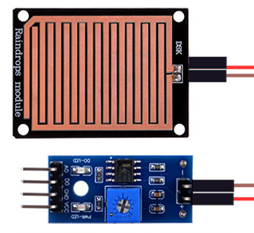

### Pinout

* VCC -Connect to 3.3V/5V power supply
* GND -Connect to Ground
* AO -Analog output
* DO -Digital output

## 1-Channel Relay Module

Relay is an electromechanical device that uses an electric current to open or close the contacts of a switch. The single-channel relay module is much more than just a plain relay, it comprises of components that make switching and connection easier and act as indicators to show if the module is powered and if the relay is active or not.

### Pinout

* VCC -Supply input for powering the relay coil
* GND -Connect to Ground.
* Normally Open -Normally open terminal of the relay
* Common -Common terminal of the relay
* Normally Closed -Normally closed contact of the relay
* Relay Trigger -Input to activate the relay

## Soil moisture sensor

The Resistive Soil Moisture Sensor Module consists of two probes which are used to measure the volumetric content of water. The two probes allow the current to pass through and then it gets the resistance value to measure the moisture value. However, the major issue with resistive soil moisture sensor is the corrosion of the sensor probes. It is because it is in contact with the soil while there is also a DC current flowing which causes electrolysis of the sensors.

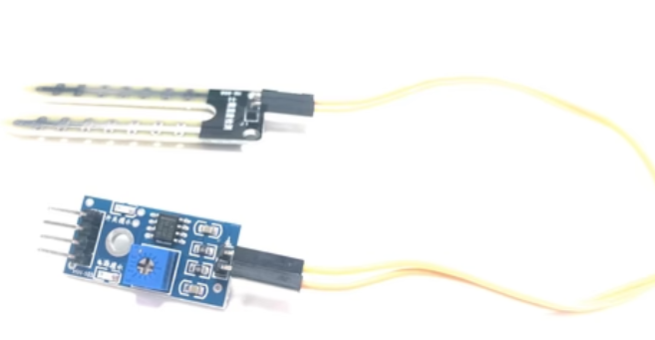

This sensor mainly utilizes capacitance to gauge the water content of the soil (dielectric permittivity). The working of this sensor can be done by inserting this sensor into the earth and the status of the water content in the soil can be reported in the form of a percent. This sensor makes it perfect to execute experiments within science courses like environmental science, agricultural science, biology, soil science, botany, and horticulture.

The sensor includes a fork-shaped probe with two exposed conductors that is inserted into the soil or wherever the moisture content is to be measured.

As previously stated, it acts as a variable resistor, with resistance varying according to soil moisture.

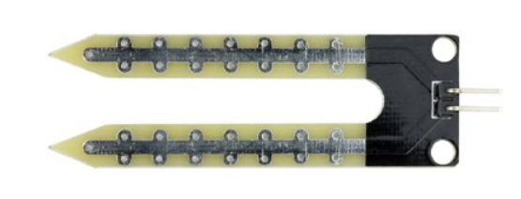

In addition, the sensor includes an electronic module that connects the probe to the Arduino.

The module generates an output voltage based on the resistance of the probe, which is available at an Analog Output (AO) pin.

The same signal is fed to an LM393 High Precision Comparator, which digitizes it and makes it available at a Digital Output (DO) pin.

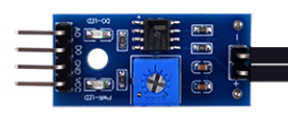

### Pinout

* VCC -Connect to 3.3V/5V power supply
* GND -Connect to Ground
* AO -Analog output
* DO -Digital output

## TF card Reader Module

TF cards are widely used in various applications, such as data logging, data visualization, and many more. TF Card Reader modules make it easier for us to access these TF cards with ease. The TF Card Reader module is an easy-to-use module with an SPI interface and an on-board 3.3V voltage regulator to provide proper supply to the TF card.

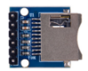

### Pinout

* VCC pin provides power to the module and should be connected to the Arduino’s 5V pin
* GND is a ground pin
* MISO (Master in Slave Out) is the SPI output
* MOSI (Master out Slave In) is the SPI input
* CLK (Serial Clock) pin accepts clock pulses from the master (an Arduino in our case) to synchronize data transmission.
* CS (Chip Select) pin is a control pin that is used to select one (or a set) of slave devices on the SPI bus.

## 1.3-inch IPS 240x240 pixels RGB Display

The built-in controller used in this LCD is ST7789VW, which is an LCD controller with 240 x RGB x 320 pixels, while the pixels of this LCD itself are 135(H) RGB x 240(V). There are two types of horizontal and vertical screens, so the internal RAM of the LCD is not fully used.  
The LCD supports 12-bit, 16-bit and 18-bit input color formats per pixel, namely RGB444, RGB565, RGB666 three color formats, this demo uses RGB565 color format, which is also a commonly used RGB format. The LCD uses a four-wire SPI communication interface, which can greatly save the GPIO port, and the communication speed will be faster.

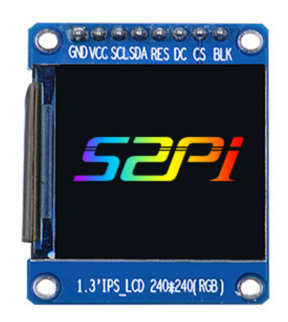

### Pinout

* VCC: Power (3.3V/5V input)
* GND: Ground
* DIN: SPI data input
* CLK: SPI clock input
* CS: chip selection, low active
* DC: Data/Command selection (high for data, low for command)
* RST: Rest, low active
* BL: Backlight

## Temperature & Humidity Sensor

This is a basic, digital temperature and humidity sensor. It uses a capacitive humidity sensor and a thermistor to measure the surrounding air and spits out a digital signal on the data pin (no analog input pins needed). It's fairly simple to use but requires careful timing to grab data. This sensor can be easily interfaced with any microcontroller to measure humidity and temperature instantaneously.

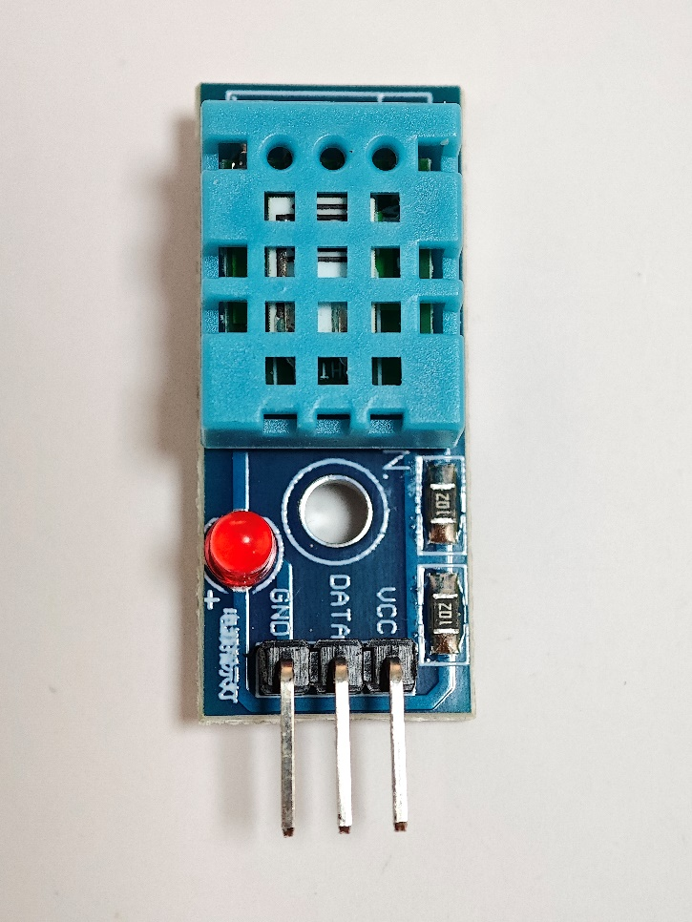

Only three pins are available for use: VCC, GND, and DATA. The communication process begins with the DATA line sending start signals to, and Temperature and humidity sensor receives the signals and returns an answer signal. Then the host receives the answer signal and begins to receive 40-bit humidity and temperature data (8-bit humidity integer + 8-bit humidity decimal + 8-bit temperature integer + 8-bit temperature decimal + 8-bit checksum).

### Pinout

* GND/- -Connect to Ground
* VCC/+ -Connect to 3.3V/5V power supply
* DATA -Data output

## External EEPROM Module I2C AT24C02 2MB

External EEPROM Module I2C AT24C02 2MB.

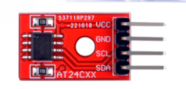

### Pinout

* VCC：3.3-5V
* GND：ground
* SCL：Arduino analog input 5
* SDA：Arduino analog input 4

## Photosensitive sensor

This is a simple photosensitive resistance sensor module. The sensor has a digital output that will go high if light is detected above a threshold set by the modules potentiometer. Additionally there is also an analogue output which will vary between 0 and 5V depending on the amount of light hitting the sensor.

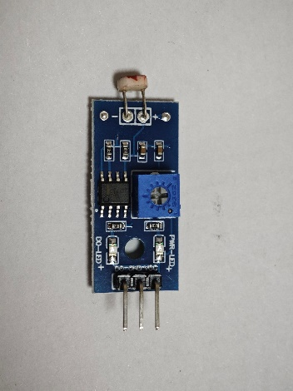

### Pinout

* VCC：3.3-5V
* GND：GND
* DO：digital output

## ESP01S Serial-to-WiFi Module

The external size of the module is 14.3mm*24.8mm*3mm, as is illustrated in Figure below. The type of flash integrated in this module is an SPI flash, the capacity of which is 1 MB, and the package size of which is SOP-210mil.

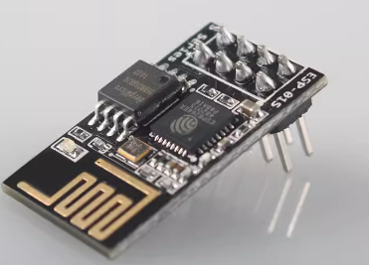

### Pinout

* VCC：3.3V
* GND：GND
* GPIO2：GPIO, Internal Pull-up
* GPIO0：GPIO, Internal Pull-up
* RXD：UART0, data received pin RXD
* RST：External reset pin, active low, Can loft or external MCU
* CH_PD：Chip enable pin. Active high
* TXD：UART0,data send pin RXD

## IR-receive module

The VS1838 IR Receiver Module detects infrared (IR) in the spectrum commonly used for IR remote control or IR intrusion sensors.

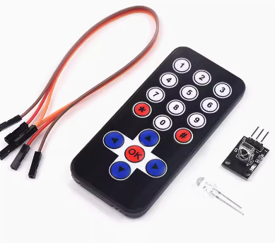

### Pinout

* ‘-‘  pin        =  Connect to Ground
* Center pin =  Connect to VCC (3.3-5V)
* ‘S’ pin        =  Connect to digital input pin on MCU

## CAN BUS Module

High-speed CAN transceivers with up to 8 Mbit/s transmission speed for automotive and many other applications.

Initially, the CAN technology was invented to offer robust and scalable networks in the car. With faster data rates it turned out to be more difficult to keep this robustness. Developing complex networks with low data rates e.g., 500 Kbit/s or 1 Mbit/s had been comparably easy. Faster networks using 2 Mbit/s or 5 Mbit/s data rate could be only realized in smaller and less complex networks.

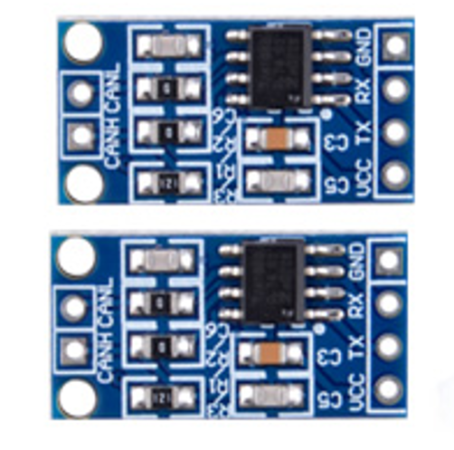

### Pinout

* CANH: High-level CAN bus line
* CANL: Low-level CAN bus line
* VCC: Supply voltage
* TX: transmit data input; reads in data from the CAN controller to the bus line drivers
* RX: receive data output; reads out data from the bus lines to the CAN controller
* GND: ground

## Buzzer

2 x Buzzer. A buzzer or beeper is an audio signaling device, which may be mechanical, electromechanical, or piezoelectric (piezo for short). Typical uses of buzzers and beepers include alarm devices, timers, train and confirmation of user input such as a mouse click or keystroke.



## Press button

6 x Press button.

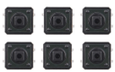

## Button cap

6 x Button cap.

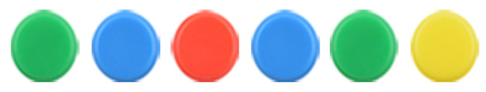

## 220-Ohm Resistor

20 x 220-Ohm Resistor

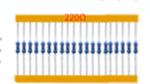

## LED indicator pack

20 x LED (Five red, yellow, blue and white).



## Battery cap

A 9V battery cap.

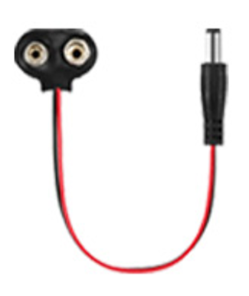

## Female-to-Male DuPont wire

40 x Female-to-Male Jumper wire.

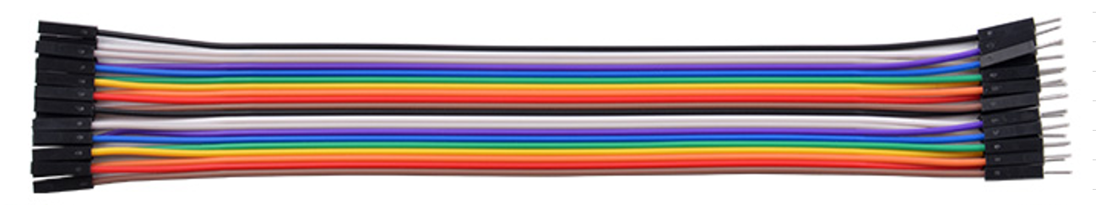

## Male-to-Male DuPont wire

20 x Male-to-male Jumper wire.

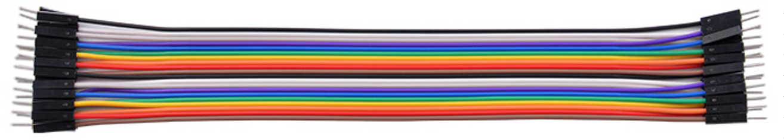

## Breadboard Jumper wire

20 x Breadboard Jumper wire

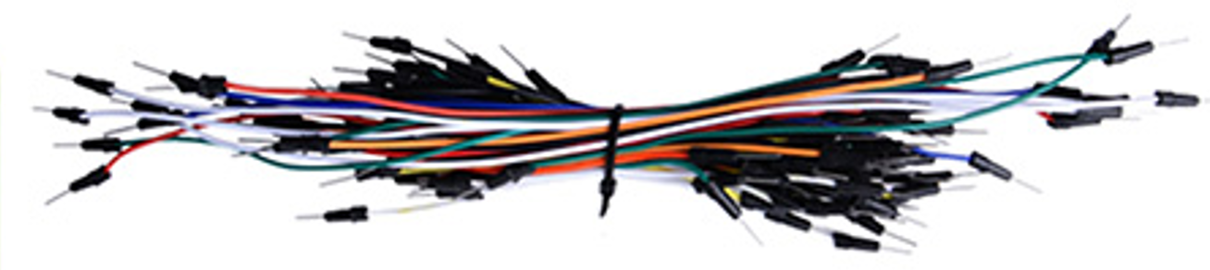

## Long Breadboard

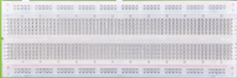

## 52Pi Experiment Platform

An experiment platform.

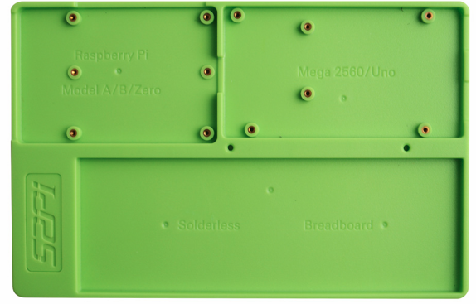

## Flash drive

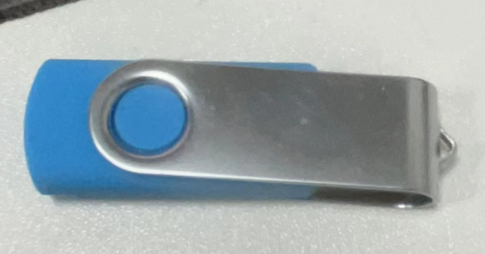

## USB-C Programing Cable

